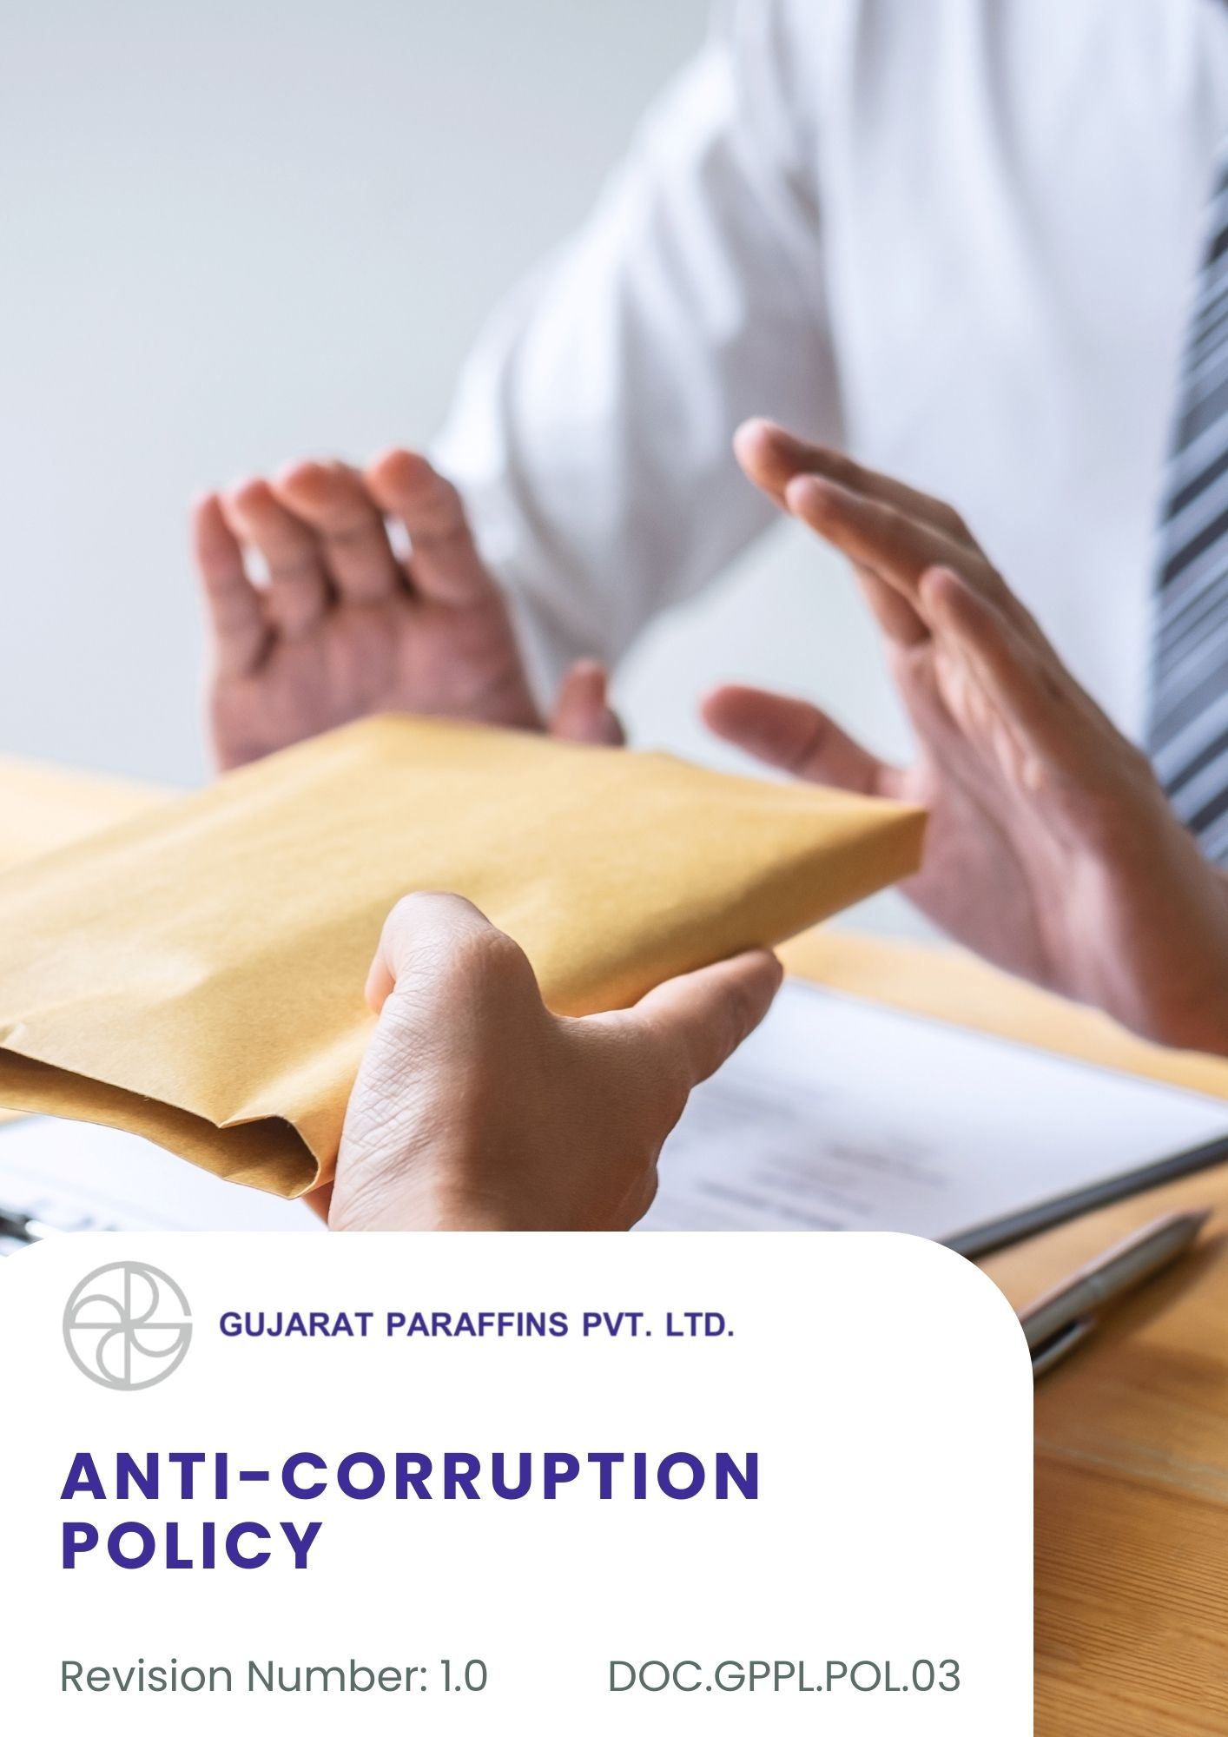
Contents

Introduction 3
Scope 3
Purpose 3
Key Focus Areas 4
Commitments 4
Targets 5
Consequences of Non-Compliance of this policy 5
Employee Practice Guidelines 6
Zero Tolerance Statement 9
Whistleblower Reporting Procedure 9
Gifts, Hospitality & Entertainment 9
Roles and Responsibilities 10
Compliance 11
SDGs Covered 12
Reporting 12
Continuous Improvement 12
Review Mechanism 12
Acknowledgement 13

Introduction
Gujarat Paraffins Pvt. Ltd. is committed to conducting its business with the highest standards of integrity, transparency, and ethical behavior. The Company firmly believes that sustainable growth can only be achieved through honest practices and strict adherence to applicable laws and regulations. Gujarat Paraffins maintains a zero-tolerance approach toward all forms of corruption, bribery, fraud, and unethical conduct, whether direct or indirect.
This Anti-Corruption Policy outlines the principles and expectations that guide our interactions with employees, customers, suppliers, business partners, government authorities, and other stakeholders. It aims to promote a culture of accountability and fairness across all levels of the organization. All employees and associated parties are expected to understand and comply with this policy and to report any suspected violations. By upholding these standards, Gujarat Paraffins Pvt. Ltd. reinforces its commitment to responsible corporate governance and ethical business practices.

Scope
This policy applies to all operational locations of Gujarat Paraffins Pvt. Ltd., including manufacturing units and the corporate office. It covers all employees, contractors, suppliers, and all stakeholders (both internal and external). The policy applies to the following locations:
Sr. No | Unit | Address
1 | Corporate Office | 401/402 Sarthik Square Nr. GNFC Tower Sarkhej-Gandhinagar Highway Ahmedabad - 380054
2 | Factory | C-1/29, Gujarat State Highway 71, G.I.D.C. Estate, Kalol, Gujarat 382725

Purpose
The purpose of this Policy is to establish a robust framework for preventing, detecting, and addressing corruption, bribery, and unethical practices at Gujarat Paraffins Pvt. Ltd. It aims to promote a culture of integrity, transparency, and accountability across all operations, ensure compliance with applicable laws and regulations, safeguard the Company’s reputation, and guide employees, management, and business partners in conducting business ethically and responsibly.

Key Focus Areas
- Preventing all forms of bribery, corruption, and unethical conduct across operations.
- Strengthening governance structures, internal controls, and leadership accountability.
- Promoting ethical behavior through training, communication, and clear codes of conduct.
- Ensuring ethical practices among suppliers, contractors, agents, and other business partners.
- Regulating gifts, hospitality, donations, and managing conflicts of interest transparently.
- Encouraging safe, confidential reporting of concerns without fear of retaliation.

Commitments
- A zero-tolerance approach to bribery and corruption will apply at all times, reinforced through leadership accountability and consistent enforcement of controls.
- Ethical governance will be strengthened through the effective implementation and periodic review of the Anti-Corruption Policy and management oversight to prevent corrupt practices across operations.
- Governance frameworks and internal control mechanisms, such as approval matrices, segregation of duties, authorization limits, and periodic internal reviews, are expected to strengthen progressively to enhance transparency and prevent conflicts of interest or misuse of authority.
- New internal control measures, such as basic approval procedures, clear role separation, and written declarations of conflicts of interest, will be implemented to improve transparency and reduce the risk of unethical behavior or misuse of authority.
- Regular identification, assessment, and mitigation of corruption risks will be undertaken through structured risk assessments, audits, and monitoring activities.
- Clear thresholds, approval mechanisms, and documentation requirements are to be implemented for gifts, hospitality, donations, and sponsorships to ensure transparency.
- Anti-corruption expectations will extend to suppliers, contractors, and other third parties through due diligence, formal commitments, ongoing monitoring, and appropriate corrective or disciplinary actions.
- Awareness of anti-corruption standards will be enhanced by conducting periodic training and communication programs to ensure employees understand prohibited practices and expected ethical behaviour.

Targets
- The number of confirmed cases of corruption or bribery is targeted to remain at zero on an annual basis through FY 2030–31, baseline year FY 2022–23.
- Full compliance 100% with the Anti-Corruption procedure across all business functions is targeted by FY 2030–31 through structured training, monitoring, and integration into operational processes from the baseline 2022-23.
- Aim to 100% compliance with all applicable laws, statutory requirements, and regulatory obligations across business and manufacturing operations by FY 2030–31, baseline year FY 2022–23.
- Anti-corruption controls embedded in 100% of critical and high-risk processes are targeted by FY 2030–31, supported by regular risk assessments and internal audits from the baseline 2022-23.
- At least one structured corruption risk assessment per year covering business operations and third-party engagements shall be conducted through FY 2030–31, baseline year FY 2022–23.
- A formal whistleblower or grievance reporting mechanism shall be accessible to 100% of employees by FY 2030–31, baseline year FY 2022–23.

Consequences of Non-Compliance of this policy
Gujarat Paraffins Pvt Ltd maintains strict standards of ethical conduct. Any non-compliance with this Anti-Corruption Policy will be addressed decisively and in line with the Company’s disciplinary framework.
- The Company will examine all reported or suspected violations through a structured and confidential review process led by authorized functions such as HR, Compliance, or designated management representatives.
- Depending on the nature and seriousness of the violation, the Company may issue formal warnings or take disciplinary action deemed appropriate under internal rules.
- In cases involving significant risk or seriousness, the Company may place individuals on temporary suspension while assessments or investigations are carried out.
- Instances of repeated misconduct or grave breaches of this policy may result in separation from service in accordance with applicable company procedures and legal requirements.
- Where violations involve breach of law or regulatory obligations, the Company shall take steps to inform and cooperate with appropriate authorities.
- The Company may require individuals involved in violations to undergo corrective actions such as ethics awareness programs, retraining, or counseling to reinforce compliance expectations.
- Failure by supervisors or managers to uphold, monitor, or enforce this policy within their teams shall be treated as a lapse in responsibility and may attract disciplinary action.
- All disciplinary decisions shall be implemented in a fair, consistent, and well-documented manner to ensure transparency and accountability.
- Acts involving bribery, corruption, falsification of records, or other serious ethical misconduct shall be treated as critical violations and may result in immediate termination and legal action where applicable.
- Business relationships with suppliers, contractors, or partners found engaging in unethical or corrupt practices may be suspended or terminated by the Company.

Employee Practice Guidelines
All employees of Gujarat Paraffins Pvt Ltd are expected to follow these guidelines to prevent corruption, bribery, and unethical conduct in day-to-day operations.
1. Conflict of Interest in Operations
- Disclose any personal, financial, or relational interests that may influence business decisions.
- Avoid situations where personal gain may compromise professional judgment or duties.
- Ensure transparency in vendor, supplier, customer, and consultant interactions.
Example:
- Declaring if a family member owns or works with a supplier before participating in procurement decisions.
- Awarding contracts to relatives or close associates without disclosure or approval.
2. Gifts, Hospitality, and Entertainment
- Accept or offer gifts and hospitality only if they are modest, infrequent, and appropriate.
- Never offer or accept gifts intended to influence business decisions.
- Always follow company approval and disclosure requirements.

Example:
- Accepting a low-value corporate gift during a festival and reporting it as per policy.
- Accepting expensive electronics, cash, or luxury travel from a supplier or customer.
3. Bribery and Facilitation Payments
- Never offer, promise, give, or accept bribes or facilitation payments.
- Do not make unofficial payments to speed up approvals, permits, or services.
- Immediately report any request for bribes or improper benefits.
Example:
- Reporting a demand for unofficial payment by a third party to management or compliance.
- Paying cash to a government official to expedite a license or inspection clearance.
4. Dealings with Government Officials
- Interact with government officials in a lawful, transparent, and professional manner.
- Ensure all documentation, payments, and communications are accurate and authorized.
- Do not offer gifts, favors, or benefits to influence regulatory decisions.
Example:
- Submitting required documents and fees through official government channels.
- Offering gifts or hospitality to inspectors to overlook non-compliance.
5. Procurement and Vendor Selection
- Follow fair, transparent, and competitive procurement processes.
- Select vendors based on quality, cost, compliance, and capability—not personal relationships.
- Avoid accepting commissions, kickbacks, or personal benefits from suppliers.
Example:
- Participating in vendor selection through approved evaluation and approval procedures.
- Manipulating tender outcomes to favor a preferred supplier for personal benefit.
6. Sales, Marketing, and Business Development
- Conduct sales and marketing activities honestly and ethically.
- Do not offer improper incentives to customers, agents, or intermediaries.
- Ensure commissions and fees paid to agents are reasonable and documented.
Example:
- Offering standard commercial discounts approved by management.
- Paying undisclosed commissions to agents to secure customer orders.
7. Use of Company Funds and Assets
- Use company funds, resources, and assets only for legitimate business purposes.
- Ensure expenses are accurate, supported by documentation, and properly approved.
- Do not misuse company resources for personal gain.
Example:
- Claiming travel expenses supported by valid bills and approvals.
- Submitting inflated or fake expense claims.
8. Whistleblowing and Reporting Concerns
- Report any suspected corruption, bribery, fraud, or unethical conduct promptly.
- Use designated reporting channels without fear of retaliation.
- Cooperate fully during investigations and audits.
Example:
- Reporting suspected kickbacks observed in procurement activities.
- Ignoring or concealing unethical behavior to avoid conflict or inconvenience.
9. Record Keeping and Transparency
- Maintain accurate, complete, and truthful records of all transactions.
- Ensure no falsification, concealment, or misrepresentation of information.
- Follow company documentation and approval procedures strictly.
Example:
- Recording all payments and approvals correctly in accounting systems.
- Creating false invoices or altering records to hide improper payments.
10. Personal Responsibility and Accountability
- Understand and comply with the Anti-Corruption & Anti-Bribery Policy at all times.
- Seek guidance when in doubt about ethical conduct.
- Accept accountability for actions that violate policy or legal requirements.
Example:
- Asking HR or Compliance before accepting a gift or hospitality.
- Claiming ignorance of policy requirements after a violation.

Zero Tolerance Statement
The Company maintains a strict zero-tolerance approach toward bribery, corruption, fraud, facilitation payments, and any form of unethical business conduct. Employees, directors, contractors, suppliers, and business partners are strictly prohibited from offering, giving, soliciting, or accepting any improper advantage, whether directly or indirectly. Any violation of this policy will result in disciplinary action, which may include termination of employment or contract, legal action, and reporting to relevant authorities where required.

Whistleblower Reporting Procedure
A confidential whistleblower mechanism is maintained to enable employees and other stakeholders to report concerns related to unethical conduct, fraud, corruption, or legal violations. Reports may be submitted without fear of retaliation and are reviewed promptly and impartially. Appropriate corrective actions are taken based on investigation findings, in line with applicable laws and internal procedures.

Gifts, Hospitality & Entertainment
- Employees may offer or accept only modest, infrequent, and reasonable gifts or hospitality that support legitimate business relationships and comply with applicable laws and company policies.
- Cash, cash equivalents, expensive gifts, or lavish entertainment intended to influence business decisions or obtain improper advantage are strictly prohibited.
- Gifts or hospitality exceeding the defined internal approval threshold must receive prior authorization from management or the Compliance/HR department.
- All gifts and hospitality must be declared and accurately recorded in the company’s gift register or relevant documentation system.
- Offering gifts or hospitality to government or public officials is highly restricted and requires prior management approval.
- Non-compliance with this requirement may result in disciplinary action in accordance with company policies.

Roles and Responsibilities
At Gujarat Paraffins Pvt Ltd, effective implementation of the Anti-Corruption Policy requires clear accountability and active involvement from key functions across the organization. The following roles have specific responsibilities to ensure compliance and ethical conduct.
1. Board of Directors
- Provide ethical leadership and demonstrate zero tolerance towards corruption and bribery.
- Approve the Anti-Corruption Policy and ensure its alignment with the Company’s values and legal obligations.
- Allocate adequate resources for policy implementation, training, and monitoring.
- Periodically review corruption risk exposure, policy effectiveness, and significant incidents, if any.
2. Managing Director
- Ensure effective implementation of the policy across all operations and business units.
- Promote a strong ethical culture through leadership example and communication.
- Ensure corrective actions are taken for identified risks or violations.
- Support independence and effectiveness of compliance and reporting mechanisms.
3. Compliance Officer
- Act as the primary owner of the Anti-Corruption Policy.
- Review the entire policy regularly
- Develop, implement, and monitor anti-corruption controls and procedures.
- Receive, assess, and coordinate investigation of reported concerns or violations.
- Maintain records of complaints, investigations, outcomes, and corrective actions.
- Conduct periodic risk assessments and recommend improvements.
4. Human Resources (HR) Department
- Integrate anti-corruption requirements into employee onboarding, training, and performance management.
- Ensure disciplinary actions for confirmed violations are implemented in line with company procedures.
- Maintain employee declarations related to conflicts of interest and policy acknowledgement.
- Support awareness programs and ethical culture initiatives.
5. Procurement and Supply Chain Function
- Ensure ethical sourcing and fair procurement practices.
- Conduct due diligence and integrity checks for suppliers, contractors, and agents, as applicable.
- Ensure anti-corruption clauses and expectations are included in supplier contracts and agreements.
- Monitor supplier compliance and report any suspected unethical conduct.

6. Finance and Accounts Department
- Ensure transparency and accuracy in financial records, payments, and accounting practices.
- Monitor transactions for unusual, unauthorized, or high-risk payments.
- Ensure appropriate approvals and documentation for expenses, gifts, donations, and sponsorships.
- Support internal and external audits related to corruption and fraud risks.
7. Employees and Contract Workers
- Comply with this policy and all applicable anti-corruption laws at all times.
- Avoid engaging in or facilitating bribery, corruption, or unethical conduct.
- Promptly report any suspected or actual violations of this policy.
- Cooperate fully with investigations and audits.
8. Third Parties (Suppliers, Contractors, Agents, and Business Partners)
- Adhere to the Company’s anti-corruption standards while working with or on behalf of Gujarat Paraffins Pvt Ltd.
- Refrain from offering or accepting bribes or improper benefits.
- Cooperate with due diligence, audits, and investigations as required.
- Accept consequences, including termination of contracts, in case of policy violations.

Compliance
The Company is committed to full compliance with all applicable anti-corruption, anti-bribery, and anti-fraud laws and regulations. We promote a culture of integrity, ethical conduct, accountability, and transparency across all business activities and relationships.

SDGs Covered
 | 

Reporting
Compliance with the anti-corruption policy will be monitored through periodic reviews, internal controls, and audits. Any suspected or confirmed incidents of bribery or corruption will be reported to senior management and addressed promptly, with corrective actions taken to strengthen controls and ensure ongoing compliance.

Continuous Improvement
We are committed to the continuous improvement of our Anti-Corruption Policy by regularly updating it to reflect evolving regulations and best practices, enhancing employee awareness and training, strengthening internal controls and risk management, and progressively improving third-party due diligence and reporting mechanisms. Leadership accountability and ethical governance will be reinforced over time to ensure ongoing prevention, detection, and timely resolution of corruption risks across all operations.

Review Mechanism
- The Compliance Officer will review this Policy annually or sooner if required due to changes in legal requirements, business operations, or organizational structure and recommend updates to senior management.
- Inputs from audits, investigations, employee feedback, and regulatory reviews shall be considered.
- Revised versions of the policy shall be communicated to all employees and relevant stakeholders.

Approved By: General Manager
(Name of GM)

Employee Acknowledgement Form
I, the undersigned, acknowledge that I have received, read, and understood the Anti-Corruption Policy of Gujarat Paraffins Pvt Ltd. I understand the Company’s commitment to ethical conduct, transparency, and zero tolerance towards corruption.
I understand that:
- I am personally responsible for complying with this policy and applicable anti-corruption laws.
- I must not offer, accept, or facilitate any form of bribery or unethical benefit.
- I must report any suspected corruption, bribery, or unethical conduct promptly and in good faith.
- Failure to comply with this policy may result in disciplinary action, including termination and legal consequences.
By signing this acknowledgement, I commit to upholding ethical standards and conducting myself in a manner consistent with this policy.
Employee Name: ____________________
Designation: ____________________
Date: ____________________
Signature: ____________________

